## **J. FRAGRANCE**

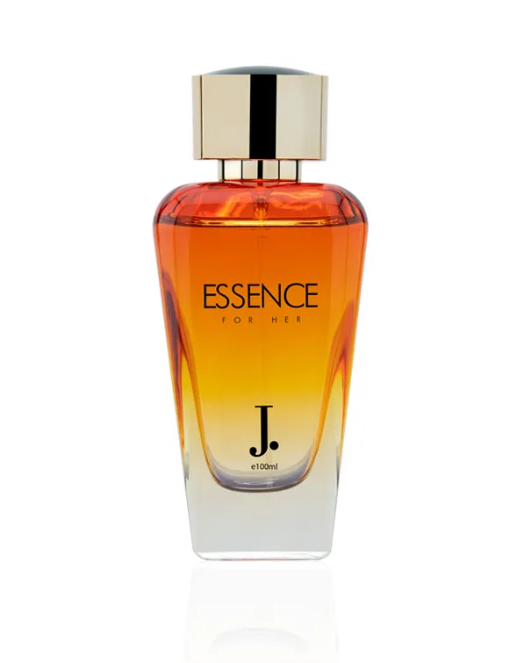

**Essence Men**



**PKR 3,525.00~~PKR 4,700.00~~**

**J. truly captures the soul of a modern woman with a character that is delicate yet intricate in its fine fragrance creation by the name of Essence. The fragrance is a passionate, graceful, and tender assortment of floral and woody origins.**

**Size: 100ml Bottle**